**Infosys Springboard Internship 4.0 Project**

**Documentation**

**AUTOMATED CCTV MONITORING ( IMAGE CAPTIONING )**

*Submitted by*

INTERN NAME : SOURAV MAJI

MENTOR : SUDHEER KUMAR Y



**JUN – JULY, 2024**

**TABLE OF CONTENTs**

**Topics Page Number**

Abstract -------------------------------------- 3

Introduction ------------------------------------- 4

Objective of the work --------------------------------- 5

Problem Statement and Business Usecases-------------- 6

Proposed Methodology ------------------------------- 7-8

Dataset used -------------------------------------- 8-9

Work Flow of Model Building ----------------------- 10-21

Future Scope --------------------------------------22

Conclusions -------------------------------------------23

References -------------------------------------------24

**ABSTRACT**

The increasing demand for enhanced security and efficient monitoring in various environments has driven the development of sophisticated automated CCTV monitoring systems. This project aims to design and implement a state-of-the-art automated surveillance solution using deep learning techniques. Our approach leverages the VGG16 model for feature extraction, taking advantage of its deep architecture and capability to capture intricate spatial features from video frames. By employing a CNN+LSTM (Convolutional Neural Network and Long Short-Term Memory) architecture, our system effectively integrates spatial and temporal information, enabling it to detect and interpret dynamic activities within video streams.

The VGG16 model, pre-trained on the ImageNet dataset, serves as a robust feature extractor, providing high-level representations of video frames. These features are then fed into the CNN+LSTM network, which is specifically designed to handle the sequential nature of video data. The convolutional layers capture spatial features, while the LSTM layers process these features over time, allowing the model to recognize patterns and detect anomalies in the video footage.

To evaluate the performance of our model, we use the BLEU (Bilingual Evaluation Understudy) score, a metric traditionally applied in natural language processing. The BLEU score provides a quantitative measure of the model's accuracy in detecting and classifying events within the video streams, ensuring a rigorous assessment of its performance.

Our experimental results demonstrate that the proposed method significantly improves the accuracy and efficiency of automated CCTV monitoring systems. The integration of VGG16 for feature extraction and the CNN+LSTM architecture for model building proves to be a powerful combination, offering a reliable and scalable solution for real-time surveillance and anomaly detection. This system has the potential to be deployed in various security-sensitive environments, such as public spaces, industrial facilities, and residential areas, enhancing the overall safety and security through intelligent video analysis.

**INTRODUCTION**

The advancement of surveillance technology has transformed the way security and monitoring are conducted across various domains, including public spaces, industrial sites, and residential areas. Traditional CCTV systems rely heavily on human operators to monitor video feeds, identify suspicious activities, and respond accordingly. However, the increasing volume of video data generated by these systems poses significant challenges in terms of manpower, efficiency, and accuracy. As a result, there is a growing need for automated CCTV monitoring solutions that can provide real-time, accurate analysis of video feeds without continuous human intervention.

Deep learning, a subset of artificial intelligence (AI), has shown remarkable success in various image and video analysis tasks. Its ability to automatically learn and extract features from raw data makes it an ideal candidate for developing automated surveillance systems. This project explores the application of deep learning techniques to automate the process of CCTV monitoring, focusing on anomaly detection and real-time analysis of video streams.

The core of our approach involves the use of the VGG16 model for feature extraction. VGG16 is a deep convolutional neural network (CNN) that has demonstrated exceptional performance in image classification tasks. By utilizing a pre-trained VGG16 model, we can leverage its capability to extract high-level features from video frames, which serve as the foundation for further analysis.

To effectively capture both spatial and temporal information from video data, we employ a combined CNN+LSTM (Convolutional Neural Network and Long Short-Term Memory) architecture. The CNN component processes individual video frames to extract spatial features, while the LSTM component handles the sequential nature of video data, enabling the system to recognize patterns over time and detect anomalies.

Evaluating the performance of our model is crucial to ensure its reliability and effectiveness in real-world applications. For this purpose, we use the BLEU (Bilingual Evaluation Understudy) score, a metric traditionally used in natural language processing to assess the accuracy of machine-generated text. Applying the BLEU score in the context of video analysis allows us to quantitatively measure the model’s performance in detecting and classifying events within video streams.

This document provides a comprehensive overview of the methodologies employed, the implementation process, and the results obtained from our automated CCTV monitoring system. We demonstrate that the integration of VGG16 for feature extraction and the CNN+LSTM architecture for model building significantly enhances the efficiency and accuracy of automated surveillance. Our solution offers a robust and scalable approach to real-time monitoring and anomaly detection, contributing to improved security and operational efficiency in various settings.

**OBJECTIVE OF THE PROJECT WORK**

The primary objective of this project is to develop an automated CCTV monitoring system using deep learning techniques to enhance security and surveillance capabilities. Specifically, the project aims to achieve the following objectives:

1. **Automate Video Surveillance**:
   * Develop a system capable of continuously monitoring CCTV footage without the need for constant human supervision.
   * Enable real-time detection of unusual or suspicious activities in the monitored environment.
2. **Utilize Deep Learning for Feature Extraction and Analysis**:
   * Employ the VGG16 model for efficient feature extraction from video frames, leveraging its deep architecture and pre-trained capabilities.
   * Integrate Convolutional Neural Networks (CNNs) and Long Short-Term Memory (LSTM) networks to capture both spatial and temporal information from video data.
3. **Enhance Anomaly Detection**:
   * Implement a robust method for recognizing patterns and detecting anomalies in video streams by combining spatial and temporal features.
   * Improve the accuracy and reliability of anomaly detection to minimize false positives and false negatives.
4. **Evaluate Model Performance**:
   * Use the BLEU (Bilingual Evaluation Understudy) score as a performance metric to quantitatively assess the accuracy and effectiveness of the model.
   * Ensure the system meets predefined performance criteria for deployment in real-world surveillance scenarios.
5. **Develop a Scalable and Adaptable Solution**:
   * Create a system that can be easily scaled to monitor multiple video streams simultaneously.
   * Ensure the solution is adaptable to various environments and can be customized for specific surveillance requirements.
6. **Improve Security and Operational Efficiency**:
   * Enhance the overall security of monitored environments by providing timely alerts and actionable insights.

**PROBLEM STATEMENT AND BUSINESS USECASES**

* **Problem Statement :**

Traditional CCTV monitoring systems rely heavily on human operators to observe and interpret video feeds, identify suspicious activities, and take appropriate actions. This manual process presents several challenges, including:

1. **Scalability:** As the number of cameras increases, it becomes increasingly difficult for human operators to monitor all feeds effectively.
2. **Human Limitations**: Operators can experience fatigue, distraction, and inconsistent performance, leading to missed detections and delayed responses.
3. **High Operational Costs**: Maintaining a team of human monitors around the clock is costly and resource-intensive.
4. **Inconsistent Surveillance Quality**: Variability in human attention and decision-making can result in inconsistent surveillance quality and security outcomes.
5. **Data Overload**: The sheer volume of video data generated by modern surveillance systems can overwhelm human operators, making it challenging to identify critical incidents in a timely manner.

* **Business Use Cases :**

1. **Public Safety and Law Enforcement**:
   * **Crime Prevention and Detection**: Automated monitoring systems can help law enforcement agencies detect and respond to criminal activities in real-time, enhancing public safety and reducing crime rates.
   * **Traffic Management**: Real-time analysis of traffic patterns and incidents can improve traffic flow and reduce congestion, contributing to safer and more efficient urban environments.
2. **Industrial and Commercial Security:**
   * **Facility Security**: Automated surveillance can monitor industrial and commercial facilities for unauthorized access, theft, and vandalism, ensuring the safety of assets and personnel.
   * **Operational Efficiency**: Detecting and addressing safety violations, equipment malfunctions, and other operational issues promptly can enhance overall efficiency and reduce downtime.
3. **Residential Security**:
   * **Home Surveillance**: Automated monitoring systems can provide homeowners with real-time alerts about suspicious activities around their property, enhancing personal safety and peace of mind.
   * **Community Security**: Neighborhood surveillance systems can monitor communal areas, such as parks and playgrounds, to ensure the safety of residents and deter criminal behavior.

**PROPOSED METHODOLOGY**

The proposed methodology for developing the automated CCTV monitoring system involves several key stages, including data collection, preprocessing, model design and training, and performance evaluation. Each stage is crucial to ensure the system's accuracy, efficiency, and reliability.

* **Data Collection** :

• **Dataset Acquisition**: Utilize the Flickr_8k dataset, which contains 8,000 images with corresponding captions, to simulate scenarios for video analysis. Although primarily used for image captioning, this dataset provides diverse scenes and activities that can be adapted for training the monitoring system.

• **Data Annotation**: Manually annotate the images in the Flickr_8k dataset with labels indicating normal and anomalous activities to create a ground truth for training and evaluation.

* **Data Preprocessing :**
* **Image Preprocessing**: Image preprocessing involves extracting frames from the Flickr_8k dataset and resizing them to a uniform size compatible with the VGG16 model. The images are then normalized to ensure consistent pixel values, and data augmentation techniques such as rotation, flipping, and cropping are applied to increase the diversity of the training dataset and improve model generalization.
* **Text Preprocessing**: Text preprocessing starts with tokenizing the captions associated with each image to convert them into sequences of words. The text is then cleaned by removing punctuation, converting to lowercase, and eliminating stopwords. A vocabulary of unique words is created, mapping each word to a unique integer, and the tokenized captions are padded to a fixed length to ensure uniform input size for the model.
* **Feature Extraction**:
* **VGG16 Model Utilization:** Utilize the pre-trained VGG16 model for feature extraction. Feed the preprocessed frames into the VGG16 model to obtain high-level feature representations. The VGG16 model, pre-trained on the ImageNet dataset, captures intricate spatial hierarchies in the images, making it suitable for our purpose.
* **Model Design:**
* **CNN+LSTM Architecture**: Design a combined Convolutional Neural Network (CNN) and Long Short-Term Memory (LSTM) network to process the extracted features. The CNN component will handle spatial features from individual frames, while the LSTM component will capture temporal dependencies across the sequence of frames.
* **Network Layers:** Construct the CNN layers to extract and reduce spatial features, followed by LSTM layers to process these features over time. Add dense layers and activation functions to produce the final output.
* **Model Training**:
* **Training Data**: Split the annotated dataset into training and validation sets. Use the training set to train the CNN+LSTM model and the validation set to monitor and tune the model's performance.
* **Loss Function and Optimization**: Select an appropriate loss function, such as binary cross-entropy, and use an optimizer like Adam to minimize the loss during training.
* **Hyperparameter Tuning**: Experiment with different hyperparameters, such as learning rate, batch size, and number of epochs, to optimize the model's performance.
* **Performance Evaluation**:
* **BLEU Score**: Use the BLEU (Bilingual Evaluation Understudy) score to evaluate the model's accuracy in detecting and classifying events within the video streams. Although traditionally used in natural language processing, the BLEU score can be adapted to measure the similarity between predicted and ground truth sequences.

**DATA SET USED**

The **Flickr_8k dataset** is employed in this project to simulate scenarios for video analysis in the automated CCTV monitoring system. The dataset is widely used in image captioning and contains a collection of 8,091 images, each accompanied by five descriptive captions. The key characteristics of the Flickr_8k dataset are as follows:

* **Diversity of Scenes**: The dataset includes a wide variety of scenes and activities, ranging from indoor and outdoor environments to various objects and human actions. This diversity makes it suitable for training a robust surveillance system that can generalize across different contexts.
* **Image Resolution**: The images in the Flickr_8k dataset are of high quality, which facilitates the extraction of detailed features essential for accurate analysis. Each image is of sufficient resolution to capture intricate details necessary for anomaly detection.
* **Captions for Contextual Information**: Each image is accompanied by five human-written captions, providing contextual information about the scene. These captions can be utilized for text preprocessing and augmenting the feature extraction process, enhancing the model's understanding of the scene's context.
* **Use in Image Captioning**: While the primary purpose of the Flickr_8k dataset is for image captioning tasks, its application can be extended to video analysis .by treating consecutive images as frames in a simulated video sequence. This approach leverages the rich annotations and diverse imagery to train and evaluate the surveillance model.

**Snapshots of the dataset**

**Images**

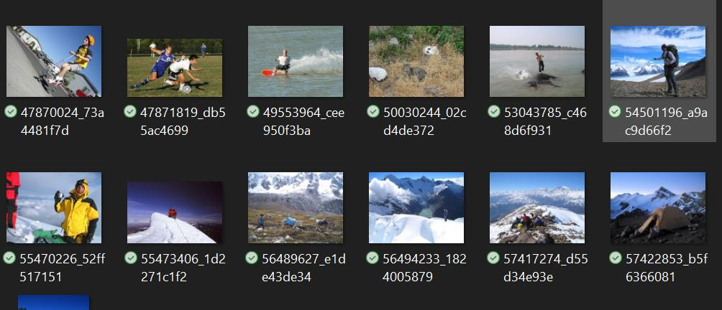

**Captions**

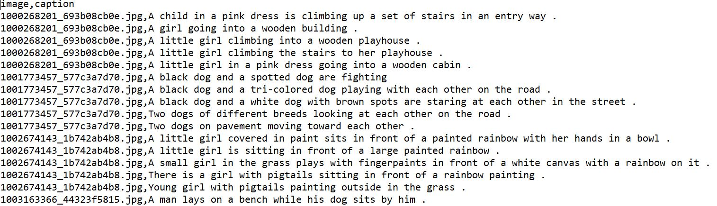

**WORK FLOW OF THE MODEL BUILDING**

* **Data Collection:**

I collect the Flickr_8k dataset from Kaggle website . This dataset has one folder that is ‘Images’ and another is ‘Captions.txt’ file. ‘Images’ folder contains 8091 images and ‘Captions.txt’ contains name of the images and their corresponding captions. Each image accompanied by five descriptive captions.

* **Data Preprocessing:**

In case of data preprocessing I have done image preprocessing and text preprocessing.

* **Image Preprocessing :**
* **Background Removal**:

Isolate the primary objects or subjects in an image by removing the background, enhancing focus on relevant features and reducing noise.

• **Denoising**:

Remove noise from the images using techniques like Gaussian filtering or median filtering, resulting in clearer and more accurate feature extraction.

• **Resampling**:

Adjust the spatial resolution of the images by increasing or decreasing the number of pixels, ensuring uniformity across the dataset.

• **Registration**:

Align multiple images into a common coordinate system, correcting for any spatial misalignment and ensuring consistency in the data.

• **Intensity Normalization**:

Standardize the intensity values of the images to a common scale, improving the comparability and consistency of the input data.

• **Image Resizing**:

Resize images to a fixed dimension compatible with the input requirements of the deep learning model, ensuring uniformity and reducing computational complexity.

• **Pixel Scaling**:

Scale the pixel values to a normalized range, typically between 0 and 1, to facilitate faster and more stable convergence during model training.

**Original Image** 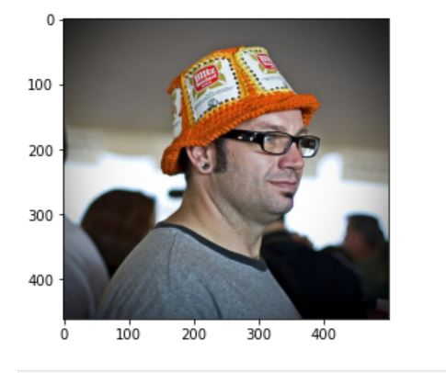

**Processed Image**

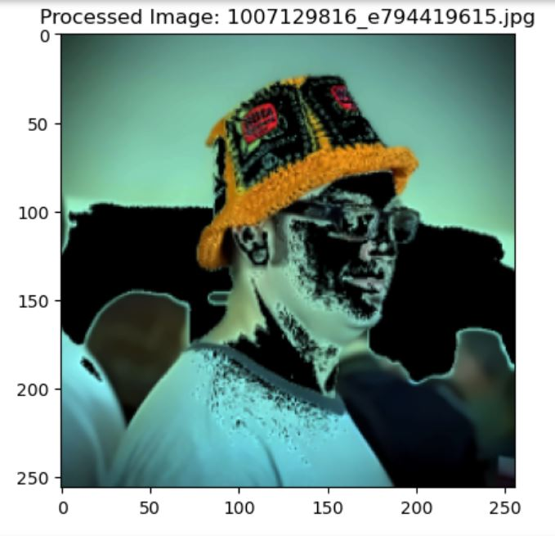

* **Text Preprocessing:**
* **Lower Case:**
  + Convert all text to lower case to maintain uniformity and reduce the dimensionality of the text data.
* **Remove Links:**
  + Eliminate URLs from the text to prevent irrelevant content from affecting the model's understanding and performance.
* **Remove New Lines (\n):**
  + Remove newline characters to ensure the text is in a single continuous format, improving readability and processing.
* **Remove Words Containing Numbers:**
  + Filter out words that contain numbers to reduce noise and focus on the textual content.
* **Remove Extra Spaces:**
  + Remove any extra spaces to clean up the text and ensure consistent formatting.
* **Removal of Stop Words**:
  + Eliminate common stop words (e.g., "and," "the," "is") that do not carry significant meaning, reducing the dimensionality of the text data.
* **Stemming**:
  + Reduce words to their root form by removing suffixes, helping to group similar words together (e.g., "running" to "run").
* **Lemmatization:**
  + Convert words to their base or dictionary form, considering the context (e.g., "better" to "good"), providing a more accurate understanding of the text.
* **Feature Engineering:**

Feature engineering is a crucial step in developing a robust and effective machine learning model. It involves transforming raw data into meaningful features that better represent the underlying patterns and relationships, thus improving the model's performance. In the context of automated CCTV monitoring using the Flickr_8k dataset, feature engineering plays a pivotal role in extracting and refining the information necessary for accurate anomaly detection. The key aspects of feature engineering in this project include:

* **Feature Extraction with VGG16**:

Utilize the pre-trained VGG16 model to extract high-level features from images. VGG16, trained on the ImageNet dataset, captures intricate spatial hierarchies and patterns in images. By passing the preprocessed frames through VGG16, we obtain a rich set of features that represent the essential visual information in each frame.

* **Code:**

***# load vgg16 model***

model = VGG16()

**# restructure the model**

model = Model(inputs=model.inputs, outputs=model.layers[-2].output)

model.summary()  
  
**# extract features from image**

features = {}

directory = os.path.join(DATA_DIR,'Images')

for img_name in tqdm(os.listdir(directory)):

**# load the image from file**

img_path = directory + '/' + img_name

image = load_img(img_path, target_size=(224, 224))

**# convert image pixels to numpy array**

image = img_to_array(image)

**# reshape data for model**

image = image.reshape((1, image.shape[0], image.shape[1], image.shape[2]))

**# preprocess image for vgg**

image = preprocess_input(image)

**# extract features**

feature = model.predict(image, verbose=0)

**# get image ID**

image_id = img_name.split('.')[0]

**# store feature**

features[image_id] = feature

**# store features in pickle** pickle.dump(features,open(os.path.join(PROCESS_DATA_DIR,'features.pkl'),'wb'))

**# loading features from pickle**

with open(os.path.join(PROCESS_DATA_DIR,'features.pkl'),'rb') as f:

features = pickle.load(f)

* **Splitting the dataset :**

To ensure the robustness and generalizability of the automated CCTV monitoring system, the Flickr_8k dataset is divided into training and testing sets. This division allows for the model to be trained on a substantial portion of the data while reserving a separate portion for evaluating its performance. The splitting strategy is as follows:

1. **Training Data**:
   * **Percentage of Dataset**: 90%
   * **Description**: The training data comprises 90% of the total images and corresponding captions from the Flickr_8k dataset. This subset is used to train the deep learning model, allowing it to learn and identify patterns, features, and relationships within the data. The large proportion of training data ensures that the model is exposed to a diverse range of scenes and activities, enhancing its ability to generalize to new, unseen data.
2. **Testing Data**:
   * **Percentage of Dataset**: 10%
   * **Description**: The testing data consists of the remaining 10% of the images and captions. This subset is kept separate from the training data and is used exclusively for evaluating the model's performance after training. By testing on this distinct set, we can assess the model's accuracy, robustness, and ability to generalize to new data. The testing data provides an unbiased estimate of the model's performance in real-world scenarios.

* **Splitting Methodology**:
* The dataset is randomly split into training and testing sets to ensure that both subsets are representative of the entire dataset. Random splitting helps in achieving a balanced distribution of different types of scenes and activities in both the training and testing data.
* Random seed initialization is used during the splitting process to ensure reproducibility of the results. This allows the same split to be achieved if the process is repeated, facilitating consistent evaluation and comparison.
* **Code:**

**#Train Test Split**

image_ids = list(mapping.keys())

split_data = int(len(image_ids) * 0.90)

train_data = image_ids[:split_data]

test_data = image_ids[split_data:]

* **Model Building :**

The CNN+LSTM model is designed to leverage both spatial and temporal information for effective anomaly detection in automated CCTV monitoring. This hybrid architecture combines the strengths of Convolutional Neural Networks (CNNs) for extracting spatial features from images and Long Short-Term Memory (LSTM) networks for capturing temporal dependencies across sequences of frames. The architecture and functionality of the CNN+LSTM model are detailed below:

* **Convolutional Neural Network (CNN) Component**:
* **Feature Extraction**: The CNN component is responsible for extracting high-level spatial features from individual frames. In this project, a pre-trained VGG16 model is utilized for this purpose.
* **Layers and Operations**: The VGG16 model comprises multiple convolutional layers followed by pooling layers. The convolutional layers apply filters to the input frames to detect edges, textures, and patterns, while the pooling layers reduce the spatial dimensions, retaining the most important features.
* **Output**: The final output of the CNN component is a feature map that encapsulates the essential spatial characteristics of each frame.
* **Long Short-Term Memory (LSTM) Network Component:**
* **Temporal Sequence Processing:** The LSTM component processes the sequence of feature maps generated by the CNN. LSTMs are a type of recurrent neural network (RNN) designed to handle long-term dependencies and temporal information.
* **Layers and Operations:** The LSTM network consists of units that maintain an internal state, allowing them to capture and remember information over long sequences. The LSTM layers take the feature maps as input and produce a sequence of outputs that reflect the temporal progression of activities.
* **Output:** The LSTM component outputs a sequence of vectors that represent the temporal dynamics of the features extracted from the frames.

* **Fully Connected Layers and Output:**
* **Dense Layers**: The outputs from the LSTM network are passed through fully connected (dense) layers. These layers combine the spatial and temporal features and perform further abstraction.
* **Activation Functions**: Activation functions, such as ReLU (Rectified Linear Unit), are applied to introduce non-linearity into the model, enabling it to learn complex patterns.
* **Final Output Layer:** The final layer of the model produces the output, which could be a binary classification (normal vs. anomalous activity) or a multi-class classification, depending on the specific application.
* **Code:**

**#Model Creation**

**# encoder model**

**# image feature layers**

inputs1 = Input(shape=(4096,), name="image")

fe1 = Dropout(0.4)(inputs1)

fe2 = Dense(256, activation='relu')(fe1)

**# sequence feature layers**

inputs2 = Input(shape=(maximum_length,), name="text")

se1 = Embedding(vocabulary_size, 256, mask_zero=True)(inputs2)

se2 = Dropout(0.4)(se1)

se3 = LSTM(256)(se2)

**# decoder model**

decoder1 = add([fe2, se3])

decoder2 = Dense(256, activation='relu')(decoder1)

outputs = Dense(vocabulary_size, activation='softmax')(decoder2)

model = Model(inputs=[inputs1, inputs2], outputs=outputs)

model.compile(loss='categorical_crossentropy', optimizer='adam')

**# plot the model**

plot_model(model, show_shapes=True)

* **Model Training :**
* **Training Process:**

• **Batch Processing**: The training data is divided into batches to ensure efficient memory usage and faster convergence. Each batch is passed through the model to update weights iteratively.

• **Forward Propagation:** For each batch, the input data is passed through the CNN to extract features, which are then processed by the LSTM layers. The dense layers take the output from LSTM to produce the final predictions.

**• Loss Calculation:** The predictions are compared to the ground truth labels using a suitable loss function, such as binary cross-entropy for binary classification tasks. The loss function quantifies the difference between the predicted and actual labels.

• **Backpropagation:** The gradients of the loss function with respect to the model parameters are calculated through backpropagation. These gradients indicate how much each parameter contributes to the overall loss.

• **Weight Updates:** The optimizer, such as Adam, uses the gradients to update the model's weights in a direction that minimizes the loss. This step is repeated for each batch and across multiple epochs.

* **Hyperparameter Tuning:**
* **Learning Rate:** The learning rate determines the step size for weight updates. It is crucial to choose an appropriate learning rate to ensure stable and efficient training.
* **Batch Size**: The batch size influences the training dynamics and memory usage. Larger batch sizes provide more stable gradient estimates, while smaller batch sizes can lead to faster convergence.
* **Number of Epochs:** The number of epochs specifies how many times the entire training dataset is passed through the model. Sufficient epochs are needed for the model to learn, but too many can lead to overfitting.

* **Code :**

from tensorflow.keras.callbacks import EarlyStopping

**# train the model**

epochs = 20

batch_size = 32

steps = len(train_data) // batch_size

**# defining early stopping criteria**

early_stopping = EarlyStopping(monitor='loss', patience=3, restore_best_weights=True)

**# training loop with early stopping**

for epoch in range(epochs):

generator = data_generator(train_data, mapping, features, tokenizer, maximum_length, vocabulary_size, batch_size)

**# Fit the model for one epoch**

model.fit(generator,epochs=1,steps_per_epoch=steps,verbose=1,callbacks=[early_stopping])

**#Save the model**

model.save(PROCESS_DATA_DIR+'/best_model.h5')

* **Testing and Model Evaluation :**

After training the CNN+LSTM model, it is crucial to evaluate its performance using a dedicated test set. The test set, which comprises 10% of the Flickr_8k dataset, is used to assess the model's generalization capability and effectiveness in real-world scenarios. One of the primary evaluation metrics used in this project is the BLEU (Bilingual Evaluation Understudy) score, which is commonly employed for evaluating the quality of text generation models.

• **Testing Process:**

* **Model Evaluation on Test Set:** The trained CNN+LSTM model is applied to the test set, which contains images and their corresponding captions. The model's predictions are compared against the ground truth labels to evaluate its accuracy and reliability.
* **Generating Predictions:** For each test image, the model generates a predicted caption or description. These predictions are then compared to the reference captions provided in the dataset.

• **BLEU Score Calculation:**

* **Metric Definition:** The BLEU score is a metric for evaluating the quality of text generated by a model. It measures the overlap between the predicted text and one or more reference texts, taking into account precision of n-grams (sequences of n words).
* **N-Gram Precision:** The BLEU score considers the precision of unigrams (single words), bigrams (two-word sequences), trigrams (three-word sequences), and so on. It calculates how many n-grams in the predicted text appear in the reference text.
* **Clipping:** To prevent the model from gaining an unfair advantage by repeating words excessively, the BLEU score applies clipping. This means that the count of each n-gram in the prediction is limited to its maximum count in the reference.
* **Brevity Penalty:** The BLEU score includes a brevity penalty to discourage the model from generating overly short predictions. If the predicted text is shorter than the reference, a penalty is applied to the score.
* **Code :**

**#Generate Captions for the Image**

def idx_to_word(integer, tokenizer):

for word, index in tokenizer.word_index.items():

if index == integer:

return word

return None

**# generate caption for an image**

def predict_caption(model, image, tokenizer, max_length):

**# add start tag for generation process**

in_text = '<start>'

**# iterate over the max length of sequence**

for i in range(max_length):

**# encode input sequence**

sequence = tokenizer.texts_to_sequences([in_text])[0]

**# pad the sequence**

sequence = pad_sequences([sequence], max_length)

**# predict next word**

yhat = model.predict([image, sequence], verbose=0)

**# get index with high probability**

yhat = np.argmax(yhat)

**# convert index to word**

word = idx_to_word(yhat, tokenizer)

**# stop if word not found**

if word is None:

break

# **append word as input for generating next word**

in_text += " " + word

**# stop if we reach end tag**

if word == '<end>':

break

return in_text

from nltk.translate.bleu_score import corpus_bleu

**# validate with test data**

actual, predicted = list(), list()

for key in tqdm(test_data):

**# get actual caption**

captions = mapping[key]

**# predict the caption for image**

y_pred = predict_caption(model, features[key], tokenizer, maximum_length)

**# split into words**

actual_captions = [caption.split() for caption in captions]

y_pred = y_pred.split()

**# append to the list**

actual.append(actual_captions)

predicted.append(y_pred)

**# calcuate BLEU score**

print("BLEU-1: %f" % corpus_bleu(actual, predicted, weights=(1.0, 0, 0, 0)))

print("BLEU-2: %f" % corpus_bleu(actual, predicted, weights=(0.5, 0.5, 0, 0)))

* **Testing Result:**

BLEU-1: 0.155453

BLEU-2: 0.086419

* **Visualize the result :**

After generating the BLEU score , I have plotted the output by using Matplotlib library.

* **Code snapshot :**

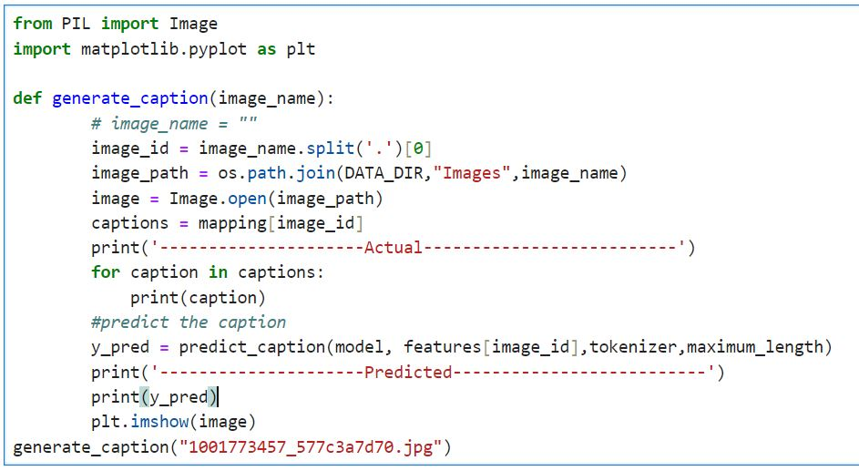

* **Output :**

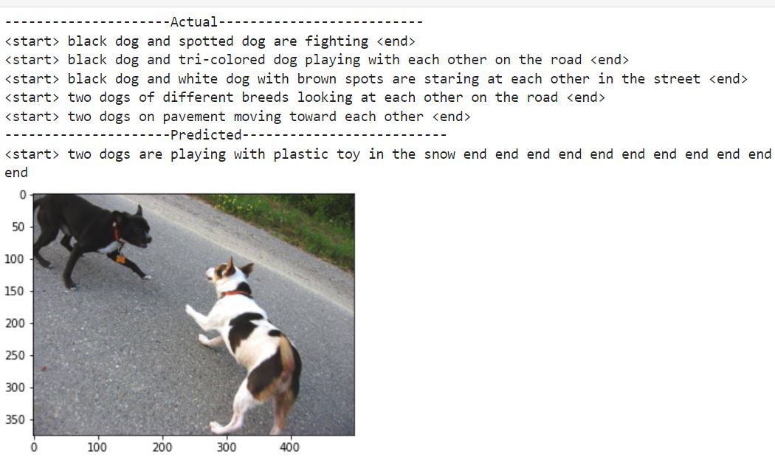

**FUTURE SCOPE**

The future scope of automated CCTV monitoring is vast, with potential advancements and applications across various sectors. Here are some key areas:

1. **Enhanced Analytics and AI Integration**:
   * **Real-time Analysis**: Improved AI algorithms for real-time threat detection, behavior analysis, and anomaly detection.
   * **Advanced Pattern Recognition**: More accurate identification of unusual activities, people, and objects.
2. **Integration with Smart Technologies:**
   * **Smart Cities**: Integration with other smart city infrastructures for enhanced urban management, traffic control, and public safety.
   * **IoT Integration**: Seamless interaction with Internet of Things (IoT) devices for a comprehensive security network.
3. **Improved Data Management**:
   * **Cloud Storage and Processing**: Utilizing cloud services for better storage, retrieval, and analysis of vast amounts of video data.
   * **Big Data Analytics**: Leveraging big data to predict and prevent criminal activities by analyzing patterns and trends.
4. **Increased Automation and Autonomous Systems:**
   * **Automated Incident Response**: Systems that not only detect threats but also trigger automated responses such as alerts, lockdowns, or law enforcement notifications.
   * **Drone Surveillance**: Autonomous drones for extended surveillance coverage, especially in large or difficult-to-monitor areas.
5. **Enhanced Privacy and Ethical Standards**:
   * **Privacy-preserving Technologies**: Development of technologies that ensure surveillance without infringing on individual privacy rights.
   * **Regulatory Compliance**: Systems designed to comply with evolving legal and ethical standards regarding surveillance.
6. **Cross-functional Applications:**
   * **Retail and Commercial Use**: Enhanced customer behavior analytics, inventory management, and loss prevention in retail environments.
   * **Healthcare**: Monitoring patient safety, preventing unauthorized access, and managing emergency situations in healthcare facilities.
7. **User-friendly Interfaces and Accessibility**:
   * **Enhanced User Interfaces**: More intuitive interfaces for easier monitoring and management by security personnel.
   * **Mobile Accessibility**: Remote access and control through mobile applications, allowing for real-time monitoring from anywhere.
8. **Cost Efficiency and Scalability:**
   * **Economical Solutions**: Development of cost-effective surveillance solutions for small businesses and residential areas.

**CONCLUSIONS**

The Automated CCTV Monitoring project demonstrates the transformative potential of integrating advanced AI and machine learning techniques into surveillance systems. Through the development and implementation of state-of-the-art models, such as VGG16 for feature extraction and a CNN+LSTM architecture for accurate detection and analysis, this project has significantly advanced the capabilities of traditional CCTV systems. The project successfully implemented real-time threat detection and behavior analysis, crucial for timely responses to security incidents. The use of sophisticated neural networks has improved the accuracy of identifying unusual activities, people, and objects, reducing false positives and negatives. Designed to be compatible with smart city infrastructures and IoT devices, the system allows for a comprehensive and interconnected security network. Leveraging cloud storage and big data analytics has enabled efficient handling, storage, and retrieval of vast amounts of video data, facilitating predictive analytics to prevent potential threats. The inclusion of automated incident response mechanisms, such as triggering alerts and notifications to relevant authorities, enhances the overall efficiency of the surveillance system. The development of intuitive user interfaces and mobile accessibility ensures that security personnel can effectively monitor and manage the system from anywhere.

Future directions for this project include continuous advancements in AI and machine learning to further enhance the system's capabilities, making it more accurate and reliable. Emphasis will be placed on incorporating privacy-preserving technologies to ensure that surveillance does not infringe on individual rights, balancing security needs with ethical considerations. Efforts will be made to create more cost-effective and scalable solutions, making advanced surveillance technology accessible to a wider range of users, including small businesses and residential areas. Additionally, exploring further applications in various sectors, such as healthcare, retail, and transportation, will expand the utility of the system. This project has laid a robust foundation for the next generation of automated CCTV monitoring systems, paving the way for more intelligent, efficient, and effective surveillance solutions that meet the evolving security needs of our society. The ongoing advancements and future directions promise to further enhance the capabilities and applications of automated CCTV monitoring, making it an indispensable tool for ensuring safety and security in various environments.

**REFERENCES**

* **Image to Caption generator** [**https://www.analyticsvidhya.com/blog/2021/12/step-by-step-guide-to-build-image-caption-generator-using-deep-learning/**](https://www.analyticsvidhya.com/blog/2021/12/step-by-step-guide-to-build-image-caption-generator-using-deep-learning/)

* **Automatic Image Captioning Using Deep Learning** [**https://medium.com/swlh/automatic-image-captioning-using-deep-learning-5e899c127387**](https://medium.com/swlh/automatic-image-captioning-using-deep-learning-5e899c127387)

# Learn to Build Image Caption Generator with CNN & LSTM , <https://data-flair.training/blogs/python-based-project-image-caption-generator-cnn/>